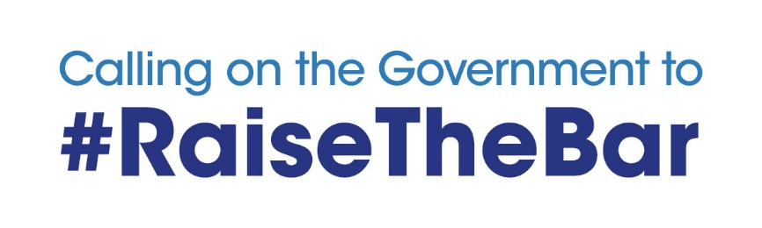
#RAISETHEBAR

CASE STUDY FORM

PLEASE NOTE: By completing this form you are giving permission for #RaiseTheBar campaign to mention your name, company and the challenge you are facing to media.

Please send all completed case study forms to Shaun Webster at Croydon BID on shaun.webster@croydonbid.com. Any questions or problems, please call Matthew Sims – 07584 430479 or email matthew.sims@croydonbid.com.

Name
Email
Phone
Business name
Business location | e.g. Bristol
Business overview | e.g. Bakery supplying to the local community and selling to restaurants and pubs in the local area
How long have you been trading? | e.g. 18 years
How has the coronavirus affected your business? | e.g. I closed doors on 19 March and haven’t been able to bake or sell any produce since then. Not made a penny
Is the rateable value of your business over £50,000 – please provide the exact figure | Yes - £120,000
How many people do you employ?  Have you had to furlough staff or make redundancies? | 20 people  Have had to furlough everyone except me
How long will your business survive without a Government grant or loan? | 45 days with our cash reserves. After that, we won’t be able to trade anymore and myself and employees will be out of a job
Have your tried to secure a loan? If yes, please share details of your experience [positive or negative] | Yes – we went to a High Street bank and they offered a loan but wanted to charge 18% interest which we didn’t want to sign up to and frankly, can’t afford  We also tried to access a Government backed loan, but when it was announced that personal guarantees were no longer required, an offer that had been made by a bank was retracted with no explanation
If businesses like yours are unable to survive the coronavirus, what will be the impact on your local community? | [Be honest, polite and clear]
If you could get a message to the Chancellor, what would you ask him? | [Be honest, polite and clear]
Please share here any other thoughts, ideas or information you think will help us strengthen the campaign and enable the campaign to be heard | [Be honest, polite and clear]

ENDS

