CANTERBURY FESTIVAL
SPONSORSHIP ANALYSIS 2018
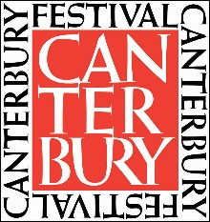
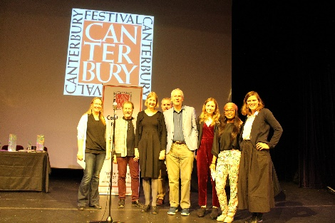

Canterbury Festival is one of Kent’s leading arts organisations, founded to commission and promote performances and exhibitions; to build future audiences; to foster creative ambition and build talent and skills, and to spearhead the cultural life of Canterbury.
Our primary focus is the annual international Festival which brings an innovative and diverse mix of classical and contemporary arts to surprise and delight local audiences. With over 200 events across numerous genres, within more than ten venues during the two-week period, it actively engages over 70,000 participants annually. Our brand profile and income generating powers are directed into year-round cultural activity for young people and communities who may not otherwise be involved with the arts. The Festival also aims to develop the talents of young people and offers opportunities to emerging artists; it commissions new work and supports those seeking a career in the cultural industries.
The Festival truly enriches the city of Canterbury and its surroundings, adding cultural and economic wealth and contributing to the wellbeing of its citizens. Annually the Festival two weeks generates approximately £3 million economic impact and the city really comes to life with a fantastic buzz around town. The public and business community continue to get involved and support the different elements of the Festival which in turn contributes to its ongoing success.
The Festival feels its role in the cultural calendar is to bringacts and performances to the city, which may not otherwise be seen. The 2018 Festival saw 40% of events at sell out or very near sell out across a vast range of genres including music, walks, talks, family friendly, performance and circus showing there is an ever-growing appetite for the Festival fortnight.
We hosted top class performers such as Sir Bryn Terfel, The Shires, Sophie Ellis-Bextor and the Feeling in the Marlowe, alongside the brilliantly talented Dutch physical performers and musicians Werelband with their performance of Slapstick.
The much loved and unique Spiegeltent was brought back as another performance venue for its sixth year. Its new home in the Coach Park is by far the best yet. The central location gave improved visibility for passers by and also easier access for the audience to and from the city centre. As per previous years, Spiegeltent performances included free Schools concerts, family events such as Children are Stinky and the Slightly Fat Show, circus by The Barely Methodical Troupe, world music including The Christians, Tom Robinson and Yolanda Brown with local musicians Mampama heating up the dance floor with their infectious West African rhythms and the ever popular cabaret. The audience enjoyed relaxing the hospitatlity tent pre and post performances alongside sponsor receptions held in there.
The Festival’s participation strand Made in Kent saw competitions and performances in theatre, dance, stand- up comedy, poetry and popular music by children and young people in the region.
Success for the Canterbury Festival isn’t simply monetary, it’s also how people interact with the Festival, whether it be enjoying a paid or free event with friends and family, participating in an event, entering one of the many competitions; either as an up and coming performer, or amateur photographer or being one of our indispensable volunteers. Our passion lies with bringing the community together and celebrating incredible performances from diverse acts across the City.
The local community engage in numerous projects throughout the year, whether it be schools taking part in the Opening Parade and the workshops in the run up to this, contributions to poetry competition or photographic competition. The Festival also runs a number of outreach projects with other charities such as Catching Lives and Porchlight.
Support for Canterbury Festival from the BID and other businesses in the local community greatly helps with not only the planning and delivery of the two-week Festival but also the wider year-round community outreach programmes and workshops.
Looking ahead, 2019 is set to be another bumper year for the Festival with some incredible acts already on the line up, soon to be announced. We’re continually developing new community projects, working hard on advancing the relationship with the local community and to striving to put on another great Festival in our wonderful City!

