bOing! International Family Festival 2018
Evaluation Report Canterbury Connected

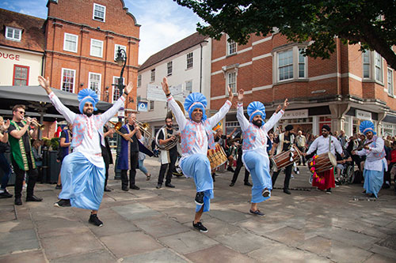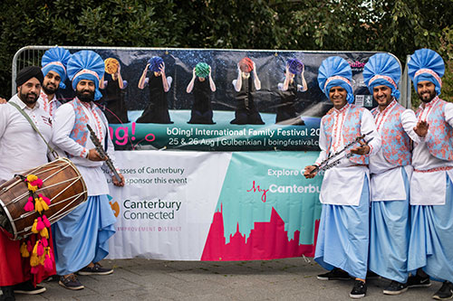

Attendance

Boing! 2018 saw the site hit by rain on the Sunday. Despite that ticket sales and attendance remained good, with outdoor events moved into an indoor space from lunchtime Sunday.

Tickets sales for events on Saturday and Sunday sold well in advance, with audiences now booking earlier to ensure they get tickets for the smaller venues. Ticket sales were slightly down on 2017, but mainly due to the impact of the Luminarium, which was badly hit on Sunday losing 1,000 tickets compared to 2017.

On the Friday we took Cohesion Plus and 4x4 Bhangra to the town centre in a really vibrant display starting at the Marlowe Theatre and promenading through the city centre. An estimated 2,500 people saw the city centre performances.

Audience Feedback

We continue to get excellent feedback from audiences with a 93% excellent/good score, although with was down from 97% in 2017, feedback indicates this was down to the wet Sunday.

We continue to attract new audiences, 25% of surveys collected were from new attenders, and around a third of people attended across both days.

Impact of BID Funding

Every year we look to take an element of bOing! out into the community. In 2019 we invited Cohesion Plus and 4x4 Bhangra to perform in Canterbury City Centre.

Activities like this enable us to get the message out about bOing! to a wider public, but more importantly they allow us to put high-quality arts in front of new audiences who may not have regular access to the arts normally. Our team use hand held clickers to estimate the number of people seeing public events, and we estimate that at least 2,500 people experienced the Bhangra dancing as it moved around the city centre route. These are shoppers and city centre users who are not looking for an arts experience, but got hooked into to brilliant music and colour of the Cohesion Plus team.

Support for BID was essential in helping to bring Cohesion Plus to Canterbury on Friday 24 Aug (this is an additional cost to bOing!) and allowed us to employ a photographer and film maker to capture the event. We have used elements of this in our bOing! materials, but they create an amazing record for BID, VisitKent and Canterbury partners to use in future. We want to help promote Canterbury as the vibrant, creative city that it is and being able to bring more events like this to the city centre and record them can only help with this.

bOing! 2018 review film: https://www.youtube.com/watch?v=_3eVhFNWvSA&t=3s

Dates for 2019

bOing! will take place on 24&25 August 2019.

2019 is our 50th Anniversary so we are planning a very special bOing! We are commissioning a new outdoor work by Motionhouse, who brought the dancing diggers to bOing! 2014.

We would very much like to work with Canterbury Connected again next year, and to see if we can involve more local businesses and maximise the benefit of bOing! to the whole city.

