CSP in the Park 2018 – Sponsorship Analysis – Canterbury Business Improvement District

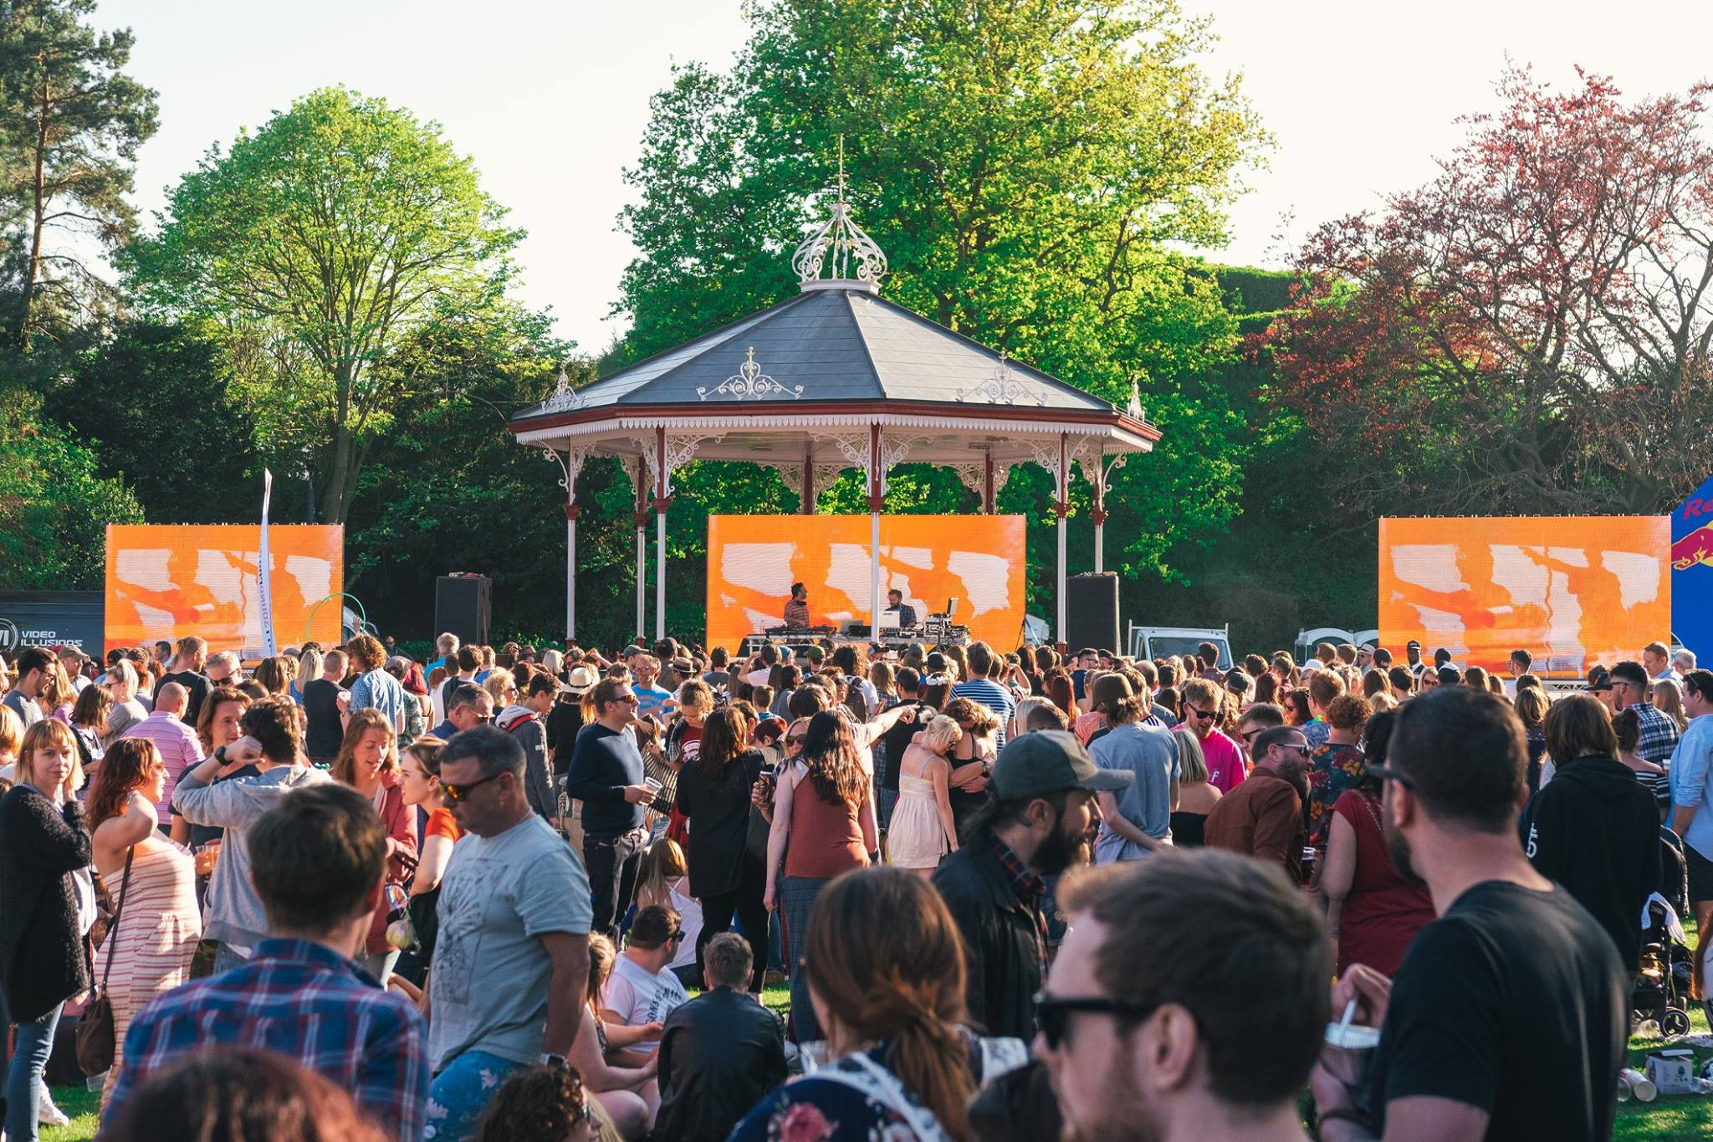

May 5th & 6th 2018 – Bank Holiday Weekend

As far as Canterbury’s Arts & Culture offering goes, CSP in the Park 2018 was a huge success. Canterbury came alive that weekend in May, with the entire City, including local businesses galvanised behind the event. We feel that as the event was free to enter the community felt some sort of ownership of it, especially as it was taking place in the Dane John Gardens (a park very close to many locals hearts). BID funding was vital in making this event happen and with an increased footfall of around 50% on 2017, we truly believe that all of our primary objectives are being achieved.

The event was somewhat blessed with absolutely stunning weather and we managed to attract an audience of over 16,000 people through the gardens over the weekend.

With the event being free to enter and there being no money generated from tickets sales, BID funding is pivotal in making this event happen. Although footfall was up by nearly 50% operating and infrastructure costs were also up by at least 50% on 2017. Fencing and security, one of the most important aspects of any event, were direct benefits of the BID investment.

This year we obviously upped our talent offering massively, by booking world famous artists such as DJ Yoda & a new firm favourite The Old Dirty Brasstards -Something that has never been done before so centrally in Canterbury. We added a second stage and collaborated with Wise Words to engage the City in new arts and music. We created workshops for children and introduced comedy and spoken word to the garden. All of which was well greatly received by the audience.

In addition to funding from the BID we managed to secure extensive support from private sponsors, who included Quinn Estates, The University of Kent, Canterbury College and Finally Ltd, with Quinn Estates and The University of Kent already confirming support for CSP in the Park 2019. We also secured a grant, for the third year running, from Arts Council England. With their funding budget being dramatically slashed in 2018, for us to still be selected for a grant is quite an achievement.

Although we have accurate footfall results for our event, it is very difficult for us to estimate how CSP in the Park has an economic impact on the city. We truly believe that the people attending the event are added to the city over the weekend. The event allows people to come and go freely and also finishes relatively early, so there are plenty of opportunities for our audience to have an economic impact within the city.

We found the marketing services offered to us from the BID, extremely useful. I believe we had a number of email shots out to the My Canterbury database and numerous banner adverts across the My Canterbury website and mobile app. With CSP in the Park being very much a family friendly event the audience of My Canterbury was an ideal one for us to advertise too. We’d be extremely keen on utilising these channels again in 2019 if the opportunity arose.

Although the coverage received by the BID was quite extensive at CSP in the Park 2018, I feel that we could If Canterbury Business Improvement district were to support CSP in the Park 2019, we could showcase the organisation more extensively, by utilising our screens and offering more advertising in our festival programme. I’d like to really to emphasise more to the community that the business’s of Canterbury so were vital in making this event happen.

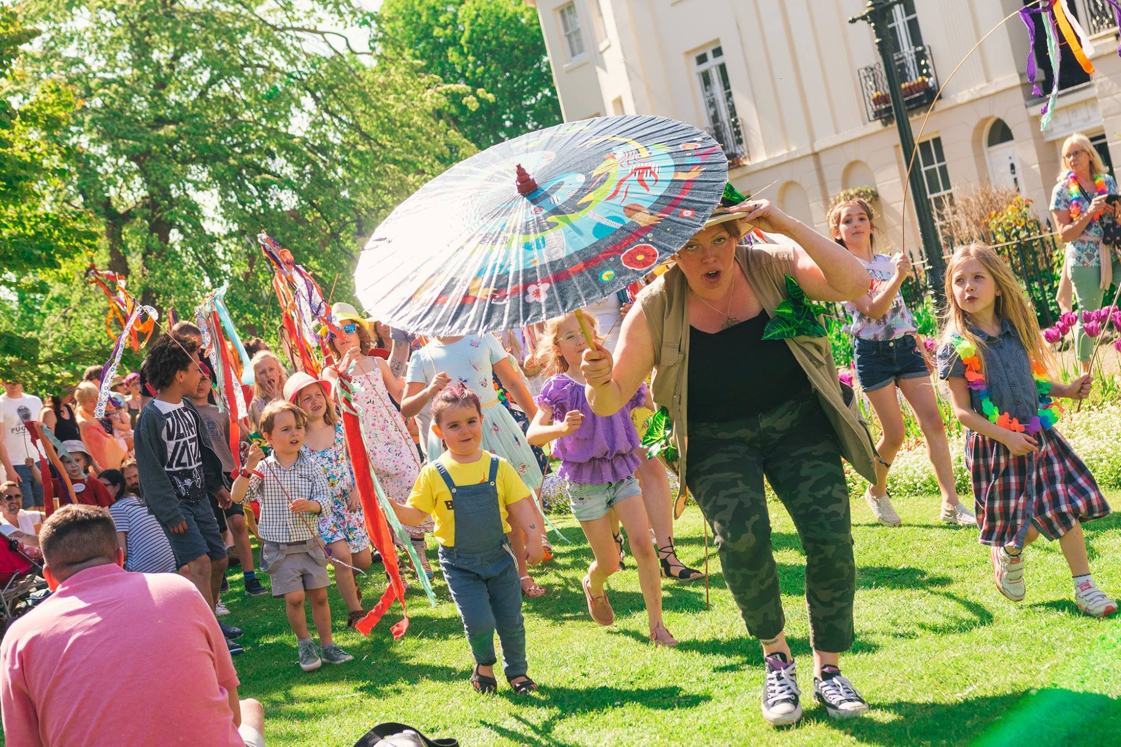

We believe that CSP in the Park has helped the city of Canterbury be viewed as more of a cultural destination and not just a site of historical importance. The city is known globally as the seat of the Church of England and, more locally, as a small university-dominated town. Thanks to CSP in the Park, I think people will view Canterbury as a place where arts & culture can flourish, which will only have a positive lasting effect on the local business’s. We hope that with a more diverse and thriving arts and culture offering Canterbury will be able to attract more visitors, therefore helping local business.

Plans are now already in place for CSP in the Park 2019 and we really value to support that Canterbury Business Improvement District offers the festival. Although this event brings joy to thousands we truly believe that this event is just as important to the local business’s as it draws so many people to the city.

Thank you, for your continued support in our dream of creating events that continue to engage the community in arts and culture. Please enjoy this short post video of our event: https://goo.gl/HVi4kR

